5 Senses Learning | - learn to  - break the  - alphabet code
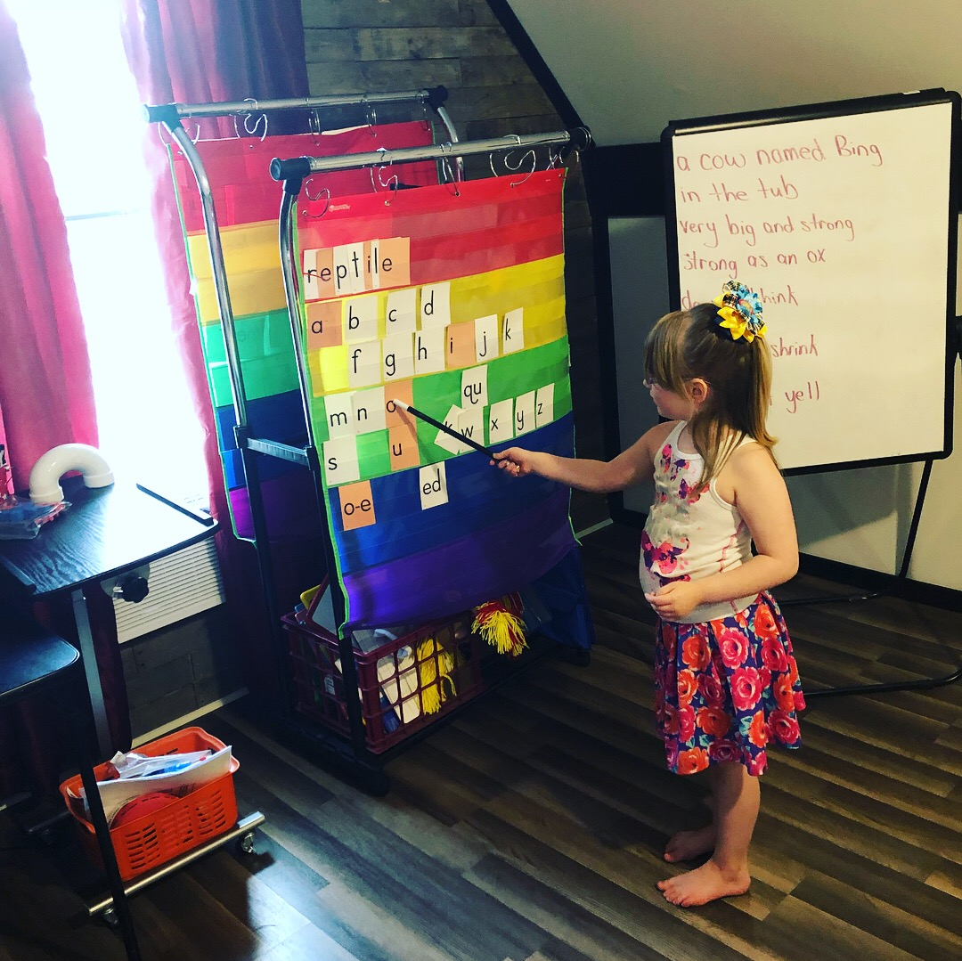  I am a certified Dyslexia Therapist and have over 10 years of experience in the classroom, small group, and individual session settings. Because of having 2 of my own children (now ages 21 and 12) struggle with dyslexia, I began learning to use and teach SMILA, an approach with which I have spent over 10 years working. SMILA is a research proven, multi-sensory approach derived from both the Orton-Gillingham and the Slingerland methods of instruction. In addition to the visual, auditory, and kinesthetic learning, I (5 Senses Learning) also incorporate our other 2 senses into teaching, taste and smell. Would you believe that your sense of smell closely correlates with memory?  Applications can be submitted online at 5slonline.org. Results from these applications will determine if there is a need to move forward to the official assessment and enrollment into the Reading Intervention Diagnostic Course. The program will consist of pre-testing to see where your child currently stands, followed by 8 weeks of sessions (16 total sessions), and then end with post-testing to show the progress made. | 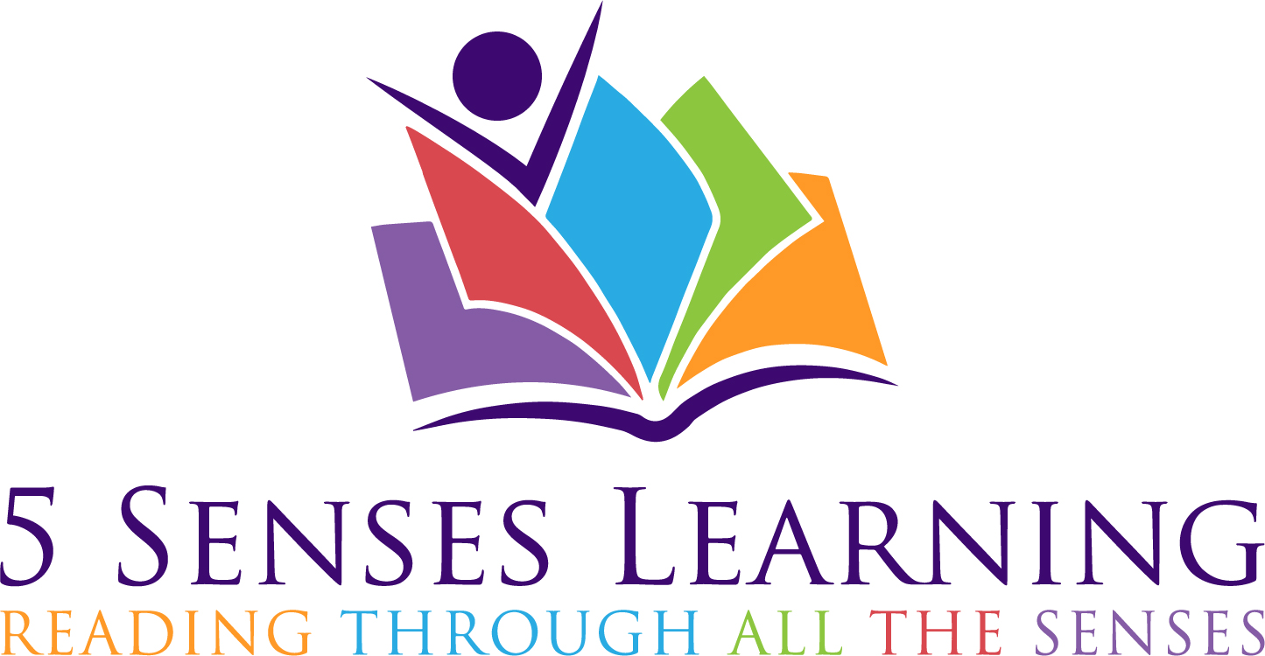  Courses will begin after Fall Break!  Call today for more information and to schedule a consultation.  (901)828-8707  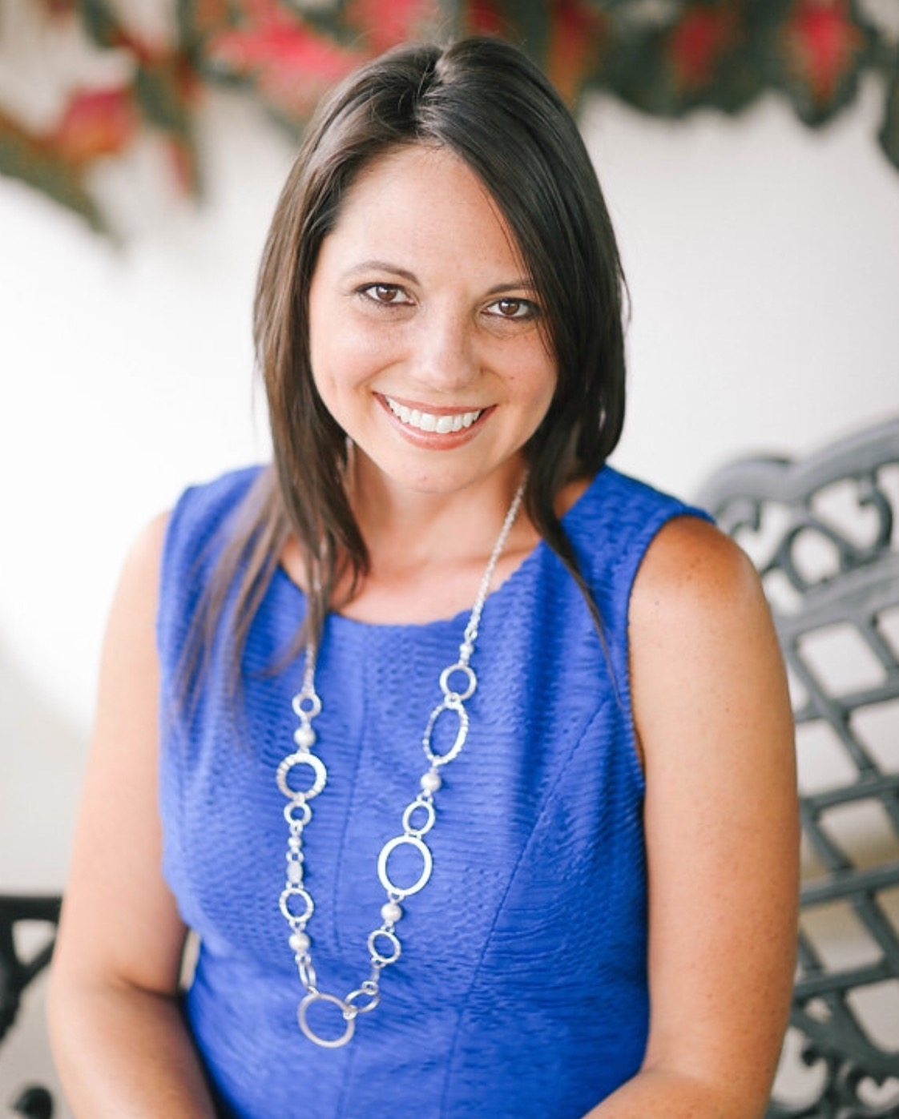  Kristia Akins  MAT, CDT, CALT, SMILA Specialist

